**Diamond Raider**

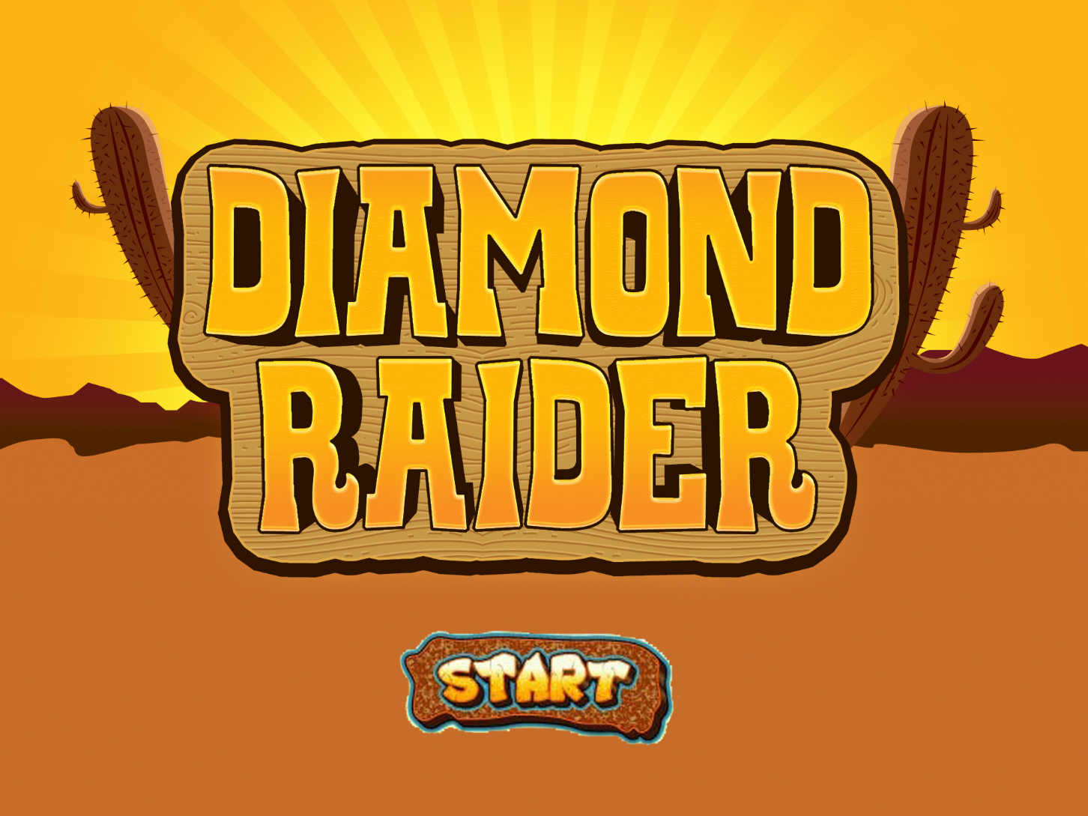

SUBMITTED BY:

**CHRISTIAN VARGAS**

**BSIT 305**

SUBMITTED TO:

**MR. RN SANTOS**

**HCI INSTRUCTOR**

**Forest Stage**

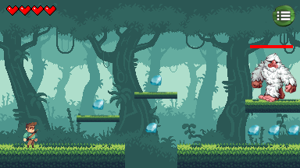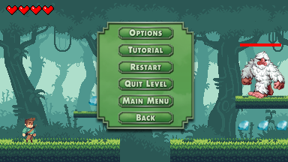

**DESERT STAGE**

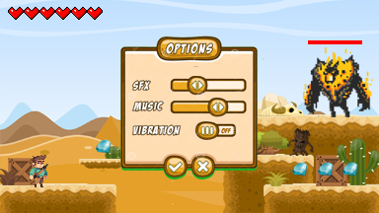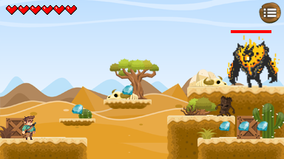

**Genre:** Action, Adventure, 2d Side Scrolling

**Target:** Ages 10 and up

**Rating:** Rated E 10+

**Number of Players:** Single Player

**Platform:** PC

**Gameplay:**

The player must COLLECT enough DIAMONDS to clear a stage. A player has FOUR LIVES and it will grow as the game progresses. Also, there are MONSTERS trying to stop you from collecting diamonds (ex. Big Foot, Zombie Tree and Molten Sand Monster)

**Story:**

A brave and young boy named Sean wants to take the same path as his father, a Raider. His mission is to collect diamonds and find the missing parts of a key that will help to find his missing mother. But it’s not going to be easy. There are monsters that protects all the diamonds, so his father Elijah gave him a magical sword to slay the monsters and complete his tasks.